How to Backup and Restore WhatsApp
- Open WhatsApp then tap on the three dots located at the top right and go to Settings.
- Go to Chats > Chat Backup and tap on “BACK UP” button. This will make sure all your recent data will be backed up locally. You can see here when your last local back up was completed.
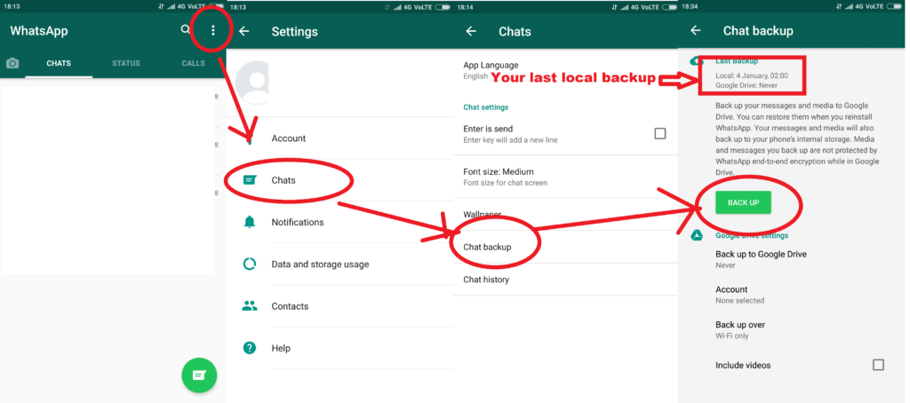
- Connect your phone to PC.
- Then select USB connection option to File Transfer on your phone.
- Open Windows Explorer then go to your device and open your phone’s internal memory, you will see “WhatsApp” folder in it.
- Copy the “WhatsApp” folder to your computer. This will be your backup folder.
- You can now restore the data by copying “WhatsApp” folder from PC to the phone’s internal memory.
- After copying the folder install WhatsApp from the Google Play Store.
- Then enter your phone number, which you were using earlier. If you enter a different number, then the backup files will not be detected, and you can end up with no backup data.
- WhatsApp will now scan for Backup Data and once the app finds it wait until the restoring process is completed.

